Assessment Task 3 – Project Review Report

Project title: Machine Learning-Based Diagnosis System for Cattle Diseases Using CNN and KNN Model: A Comparative Analysis

Student Name: Safwan Chowdhury

Student ID: B00923206

PSG Identifier: PSG-Q21

Mentor Name: Shaheer Baba

Course Title: COM668 Computing Project

Year of Submission: 2024/2025

Year of submission: 2025

Word Count (9000 Maximum):

Declaration:

I declare that this is all my own work. Any material I have referred to has been accurately referenced and any contribution of Artificial Intelligence technology has been fully acknowledged. I have read the University’s policy on academic misconduct and understand the different forms of academic misconduct. If it is shown that material has been falsified, plagiarized, or I have otherwise attempted to obtain an unfair advantage for myself or others, I understand that I may face sanctions in accordance with the policies and procedures of the University. A mark of zero may be awarded and the reason for that mark will be recorded on my file.

Abstract:

Cattle diseases pose a substantial risk to livestock output and the livelihoods of farmers. This study introduces a diagnostic method utilizing machine learning to identify two significant cow diseases: Lumpy Skin Disease (LSD) and Foot and Mouth Disease (FMD). Originally intended to encompass Anthrax and Black Quarter, they were omitted owing to the absence of publicly accessible datasets. The solution is executed utilizing Python, TensorFlow, and OpenCV, and produced by Jupyter Notebook. The system utilizes Convolutional Neural Networks (CNNs) to categorize illness pictures with high precision, providing a scalable and accessible instrument for early diagnosis and intervention.

Contents

1. Introduction

1.1. Review Initial Concept

The primary objective of this research was to develop a cloud-based diagnostic system proficient in detecting prevalent infectious illnesses in cattle by machine learning techniques. The program targeted farmers and veterinary staff as primary users, intending to expedite illness detection based on fundamental symptom inputs. The project, originally envisioned as a mobile application, transitioned to a web-based platform to facilitate wider accessibility and simpler distribution.

1.2. Aim

This project aims to enhance livestock health management by developing a CNN-based image classification system for early detection of Lumpy Skin Disease (LSD) and Foot **and** Mouth Disease (FMD). The system is built using Python and TensorFlow/Flask and flask trained on curated image datasets to deliver accurate predictions in a cloud-based environment.

1.3. Review Project Objectives   
  
1. Collect and preprocess publically accessible datasets for Lumpy Skin Disease (LSD) and Foot and Mouth Disease (FMD).  
  
2. Train and improve a CNN model utilising TensorFlow/Keras to properly categorize photos of Lumpy Skin Disease (LSD) and Foot and Mouth Disease (FMD).  
  
3. Develop a Flask-based API to deliver predictions from the trained model.  
  
4. Assess the model utilising accuracy, precision, recall, F1-score, and confusion matrix measures.  
  
5. Illustrate model performance via Matplotlib and Seaborn.

1.4 Review Project Outcomes

In the preliminary planning stage detailed in the AT2 report, the project was envisioned as a mobile application aimed at diagnosing four significant cow diseases: Foot and Mouth Disease (FMD), Lumpy Skin Disease (LSD), Anthrax, and Black Quarter using machine learning methodologies. As development advanced, a synthesis of technical feedback, feasibility evaluations, and supervisor direction resulted in a strategy shift. The scope was narrowed to concentrate just on Foot and Mouth Disease (FMD) and Lumpy Skin Disease (LSD) due to the restricted availability of publicly accessible datasets for Anthrax and Black Quarter. The distribution mechanism shifted from mobile to a web-based platform to improve scalability, accessibility, and interoperability with cloud-based development environments.

The delivery method transitioned from a mobile or multi-frontend model to a Python-based backend API utilising Flask. This modification enhanced scalability, accessibility, and compatibility with both cloud-based and local development environments, while streamlining deployment. The updated system architecture emphasizes a machine learning pipeline developed in Python with TensorFlow/Keras for training and OpenCV for image preprocessing, accessible via Flask APIs for prediction queries. This part integrates the original and revised objectives, each corresponding to project milestones and monitored by SMART criteria.

**Project Objectives Summary Table**

**T**able 1: Initial and Updated Objectives

| Objective ID | Description | Target Date | Completed Date | Status |
| --- | --- | --- | --- | --- |
| 01 | Define aims, scope, and disease coverage for the diagnostic tool (initially FMD, LSD, Anthrax, BQ) | Semester 1 | Semester 1 | ✔ |
| 02 | Draft initial concept for mobile application targeting agricultural stakeholders | Semester 1 | Semester 1 | ✔ |
| 03 | Research and compare ML algorithms suitable for veterinary diagnostics (CNN, KNN) | Semester 1 | Semester 1 | ✔ |
| 04 | Explore image dataset formats and disease annotation strategies | Semester 1 | Semester 1 | ✔ |
| 05 | Select CNN architecture and build training/testing environment using TensorFlow and Google Colab | Semester 2 | Semester 2 | ✔ |
| 06 | Refine dataset: remove Anthrax and BQ due to lack of public data; focus on LSD and FMD | Semester 2 | Semester 2 | ✔ |
| 07 | Apply image preprocessing and augmentation using OpenCV and NumPy | Semester 2 | Semester 2 | ✔ |
| 08 | Train CNN model and evaluate performance using precision, recall, F1-score, and confusion matrix | Semester 2 | Semester 2 | ✔ |
| 09 | Visualize training metrics using Matplotlib and Seaborn | Semester 2 | Semester 2 | ✔ |
| 10 | Document model architecture, training outcomes, and limitations | Semester 2 | Semester 2 | ✔ |
| 11 | Compile AT3 report with updated scope, technical justification, and evaluation | Semester 2 | Semester 2 | ✔ |
| 12 | Submit AT3 and present findings in final showcase | Semester 2 | Semester 2 | ✔ |

*Table 1.1 Initial and Up to Date Objectives*

2.1 Literature Review

Even with these improvements, there are still problems. (Erin Hennesey, 2022) stress the importance of having big, varied datasets, high-quality ground truth labels, and collaboration between different fields to make sure that models are understandable and useful in the clinic. To make diagnostic systems that can be used in different agricultural settings, it is important to fix these problems (Allen Daniel Sunny, 2018).   
A comprehensive analysis by (Deeksha G Mesta, 2023) highlights the growing application of machine learning in forecasting livestock diseases, highlighting its capacity to minimize diagnostic delays and enhance treatment results. Their study looks at a lot of different machine learning models and finds that ensemble methods, like Random Forests, work better than traditional classifiers when working with noisy or incomplete datasets. Image-based machine learning models, particularly Convolutional Neural Networks (CNNs), have demonstrated potential in relation to Foot and Mouth Disease (FMD) and Lumpy Skin Disease (LSD). (Dihua Wu, 2020) developed a YOLOv3-based deep learning model for detecting lameness in dairy cows, achieving an accuracy of 98.57%. This shows that using computer vision methods for real-time disease monitoring is possible. (Lijing Niu, 2020) proposed a hybrid methodology that combines SVM and association rule mining to correlate cattle symptoms with disease outcomes. Their method made it easier to quickly diagnose and suggest treatments, especially for diseases like Anthrax and Black Quarter, which often have similar symptoms. (Daksh Ashar1, 2021) created a livestock disease prediction system utilizing SVM and implemented it on online platforms to enhance accessibility in remote agricultural areas (Mrs. Anitha Rao, 2023). Their technology (Deeksha G Mesta, 2023) not only forecasted illness outcomes but also sent preventative alarms for potentially lethal diseases. Notwithstanding these gains, difficulties persist. (Erin Hennesey, 2022) observe that veterinary machine learning applications are hindered by restricted datasets, inaccurate labelling, and insufficient collaboration between domain experts and data scientists. Rectifying these deficiencies is crucial for developing resilient diagnostic instruments capable of generalization across breeds, geographies, and disease variations. Deep learning (DL) has become a revolutionary method for veterinary diagnostics, especially when it comes to finding diseases through images. Deep learning architectures, especially Convolutional Neural Networks (CNNs), are much better at finding hierarchical features in complex datasets than traditional machine learning models. This makes them great for finding visual patterns that are linked to cattle diseases. Recent research has shown that CNNs can accurately diagnose Lumpy Skin Disease (LSD) and Foot and Mouth Disease (FMD) by using image classification methods. (Khandait, Lanjewar, Patle, & Meshram, 2025) created a CNN-based system that tested a number of architectures, such as DenseNet121, ResNet50V2, InceptionV3, VGG16, and Xception. Their model was very accurate thanks to transfer learning and data augmentation. This makes it a scalable way to automatically keep an eye on the health of cattle. (Senthilkumar, C, Vadivu, & Neethirajan, 2024) performed a comparative analysis of pretrained models, including MobileNetV2 and VGG16, for the detection of LSD. Their system had an accuracy rate of over 96%, with high sensitivity and specificity. This shows that DL-based tools can be used in veterinary settings (Saqib, et al., 2024) also suggested a MobileNetV2 model that was improved with RMSprop. It beat existing benchmarks by 4–10% and showed that it could work well in real-world farm settings. (Jayapratha N, 2025) developed a real-time deep learning system employing high-resolution imaging and convolutional neural networks (CNNs) to identify external cattle diseases, including mastitis and foot-and-mouth disease (FMD). Their model, which was trained on a wide range of data and improved through transfer learning with ResNet, was able to reliably identify diseases in their early stages, which cut down on the amount of manual work and the time it took to make a diagnosis. (Jayapratha N, 2025) created a real-time deep learning system that uses high-resolution imaging and convolutional neural networks (CNNs) to find external cattle diseases like mastitis and foot-and-mouth disease (FMD). Their model, which was trained on a lot of different data and got better through transfer learning with ResNet, could reliably find diseases in their early stages. This cut down on the amount of work that had to be done by hand and the time it took to make a diagnosis. Even with these improvements, there are still problems. (Erin Hennesey, 2022) stress the importance of having big, varied datasets, high-quality ground truth labels, and collaboration between different fields to make sure that models are understandable and useful in the clinic. To make diagnostic systems that can be used in different agricultural settings, it is important to fix these problems.

2.2. Plans

Sprint-Based Development Timeline

| Sprint | Start Date | End Date | Key Deliverables |
| --- | --- | --- | --- |
| Sprint 1 | 01 July 2025 | 07 July 2025 | Finalize LSD and FMD datasets, clean metadata, set up Google Colab environment |
| Sprint 2 | 08 July 2025 | 17 July 2025 | Build CNN architecture using TensorFlow, apply image preprocessing and augmentation |
| Sprint 3 | 18 July 2025 | 26 July 2025 | Train model, evaluate using confusion matrix, precision, recall, and F1-score |
| Sprint 4 | 27 July 2025 | 05 August 2025 | Visualize results using Matplotlib and Seaborn, refine model, document findings |
| Sprint 5 | 06 August 2025 | 16 August 2025 | Finalize AT3 report, prepare presentation materials, submit and demonstrate project |

*Table 2.1 Initial and tentative date objectives*

2.3. Metrics   
  
**Confusion Matrix**A confusion matrix is a table that shows how well real classifications match up with projected ones. It is used to test how well categorization models work by putting predictions into four groups:  
 1. True Positive (TP): Correctly anticipated situations that are positive  
 2. True Negative (TN): Cases that were correctly predicted to be negative   
 3. False Positive (FP): situations that were wrongly thought to be positive   
 4. False Negative (FN): Cases that were wrongly anticipated to be negative   
 These numbers are used to figure out important performance measures.  
  
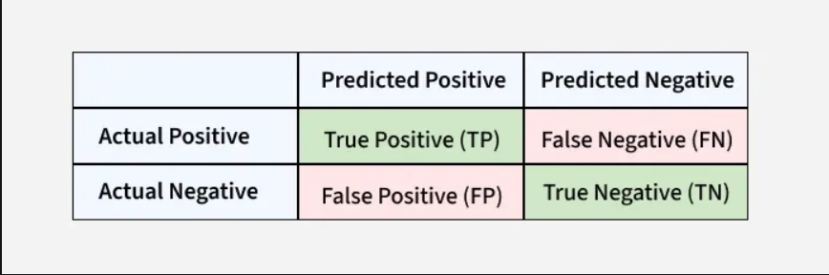   
 *Figure 2.1 Confusion Matrix* (geeksforgeeks, 2025)

Figure 2.1 represents a confusion matrix, an essential instrument for assessing the efficacy of classification models, particularly in binary or multi-class machine learning applications such as illness detection. The matrix comprises four quadrants, each signifying a distinct sort of predictive consequence:  
True Positive (TP): The model accurately identified a positive instance (e.g., correctly classifying a picture as LSD-affected).   
False Negative (FN): The model did not identify a positive example (e.g., erroneously categorizing an LSD picture as healthy).   
False Positive (FP): The model erroneously classified a negative instance as positive (e.g., designating a healthy picture as indicative of LSD).   
True Negative (TN): The model accurately recognized a negative instance (e.g., classifying a healthy picture as non-diseased).

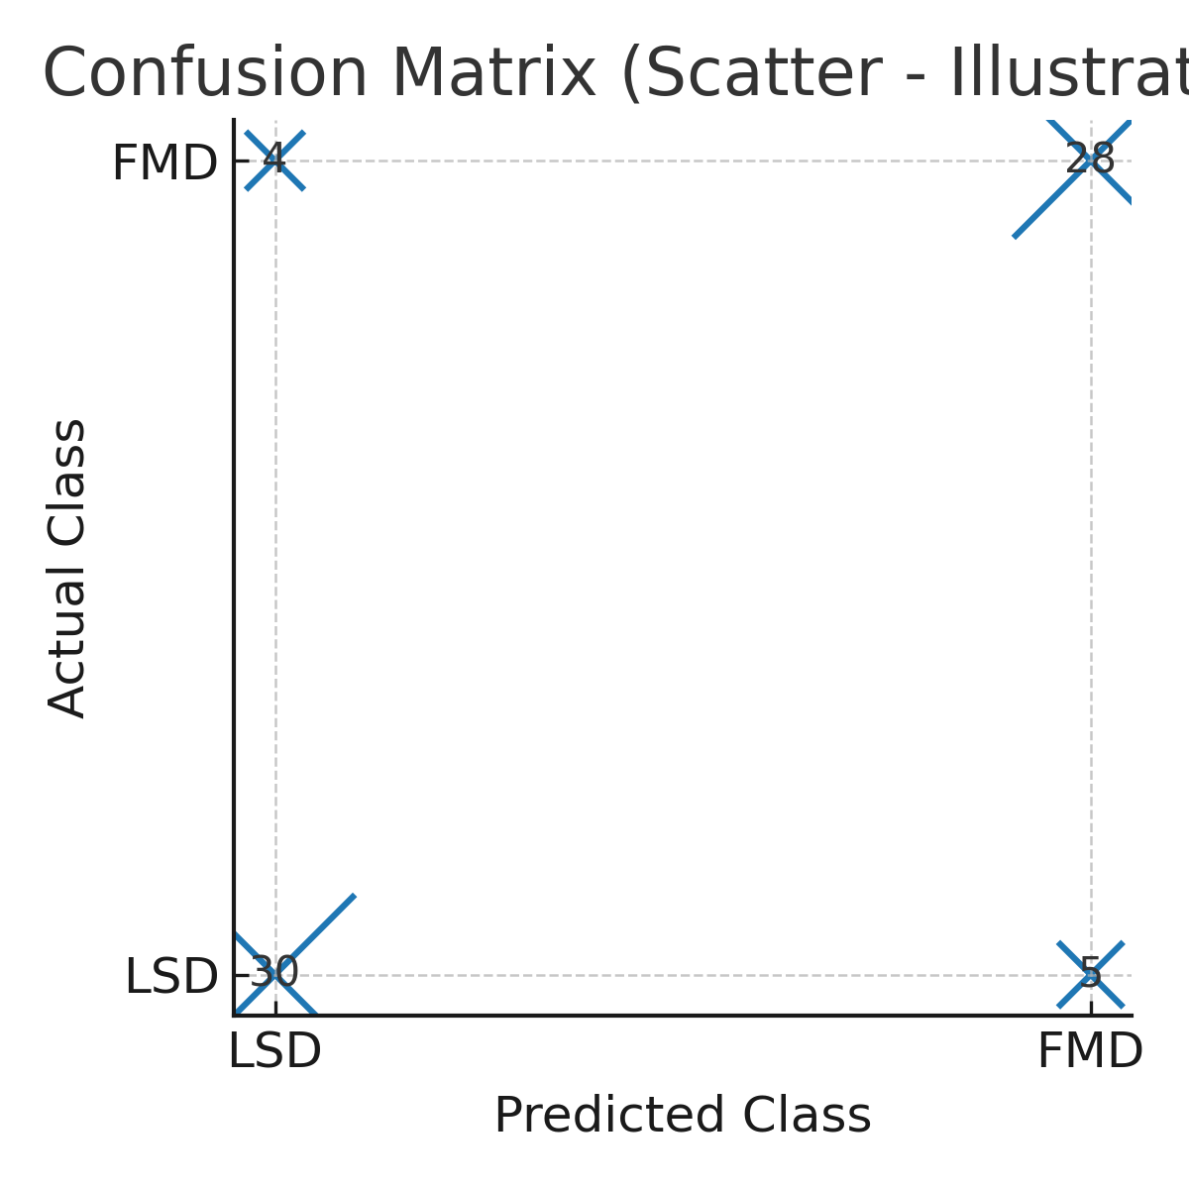

*Figure 2.2 Confusion Matrix* (Powers, 2011)  
  
Figure 2.2 illustrates a confusion matrix depicting the classification performance for Lumpy Skin Disease (LSD) and Foot and Mouth Disease (FMD). The dimensions of the bubbles correspond to the quantity of predictions for each actual-predicted class pairing. This representation emphasizes accurate classifications along the diagonal and erroneous classifications off the diagonal. (Powers, 2011)

| **Metric** | **Definition** | **Formula** |
| --- | --- | --- |
| **Accuracy** | Proportion of correct predictions over total predictions | \text{Accuracy} = \frac{TP + TN}{TP + TN + FP + FN} |
| **Precision** | Proportion of true positives among all predicted positives | \text{Precision} = \frac{TP}{TP + FP} |
| **Recall** | Proportion of true positives among all actual positives | \text{Recall} = \frac{TP}{TP + FN} |
| **F1-Score** | Harmonic mean of precision and recall | \text{F1} = \frac{2 \cdot \text{Precision} \cdot \text{Recall}}{\text{Precision} + \text{Recall}} |

*Table 2.2 Evaluation Matrix and Formulas* (F1 Score in Machine Learning: Formula, Precision, and Recall, 2025)**Deep Learning Architectures: Expanded Overview**Convolutional Neural Networks (CNNs) serve as the foundation for deep learning applications involving pictures. They are engineered to autonomously derive spatial hierarchies of attributes from incoming data via many specialized layers:  
  
Convolutional Layers: Employ trainable filters to identify local patterns, including edges, textures, and forms.  
  
Activation Functions: The Rectified Linear Unit (ReLU) is frequently utilized to include non-linearity and enhance convergence speed.  
  
Pooling Layers: Implement max or average pooling to diminish spatial dimensions, enhancing computing efficiency and translation invariance.  
  
Fully Connected Layers: Flatten feature maps and interconnect neurones for ultimate categorization.  
  
Dropout and Batch Normalization: Regularization methods employed to mitigate overfitting and enhance training stability.  
Convolutional Neural Networks (CNNs) excel in visual identification tasks because to their local receptive fields, weight sharing, and translation invariance. (Laith Alzubaidi, 2021)

MobileNetV3 is a streamlined architecture suited for mobile and embedded devices, enhancing MobileNetV2 with:  
  
MobileBottleneck Blocks: Inverted residual blocks utilising depthwise separable convolutions and optional residual connections.  
  
Squeeze-and-Excitation (SE) Modules: Channel-specific attention processes for the recalibration of feature maps.  
  
Hard-Swish Activation: Effective approximation of the Swish function.  
Hard-Swish(x) = x · ReLU6(x + 3) / 6  
  
Depthwise Separable Convolutions: Dividing convolutions into depthwise and pointwise components to minimize computational demands.  
  
MobileNetV3 is available in big and small forms, optimized by Neural Architecture Search (NAS) and NetAdapt for platform-specific deployment (Howard, 2019)

EfficientNet B7 is one of a group of models that employ compound scaling to find the right balance between network depth, width, and resolution:   
The formula for compound scaling is:   
FLOPs = Depth^α × Width^β × Resolution^γ   
MBConv Blocks: These are inverted bottleneck blocks that have depth wise separable convolutions and SE layers.   
SE Layers: Improve the ability to represent by changing the answers of each channel in a way that fits.   
Global Average Pooling: Before categorization, it turns each feature map into a single value.   
Compared to standard CNNs, EfficientNet-B7 has state-of-the-art accuracy with a lot fewer parameters and FLOPs. (Md Zahangir Alom, 2019)

ResNet152V2 is a deep residual network that uses skip connections to fix the problem of the vanishing gradient:   
Residual Mapping: The network learns the residual F(x) = H(x) - x instead of the direct mapping H(x). It then reconstructs H(x) = F(x) + x.   
Skip Connections: Let gradients go straight across levels, making it easier to train networks with more than 100 layers.   
Blocks for Pre-Activation: Batch normalisation and ReLU are used before convolutions in ResNetV2. This makes the gradient flow and convergence better.   
Identity Mapping: When the input and output dimensions are the same, the input is added straight to the output. A projection, on the other hand, lines up dimensions.   
ResNet152V2 is very good at classifying images with small details since it has a lot of representational power without slowing down. (He, Zhang, Ren, & Sun, 2016)

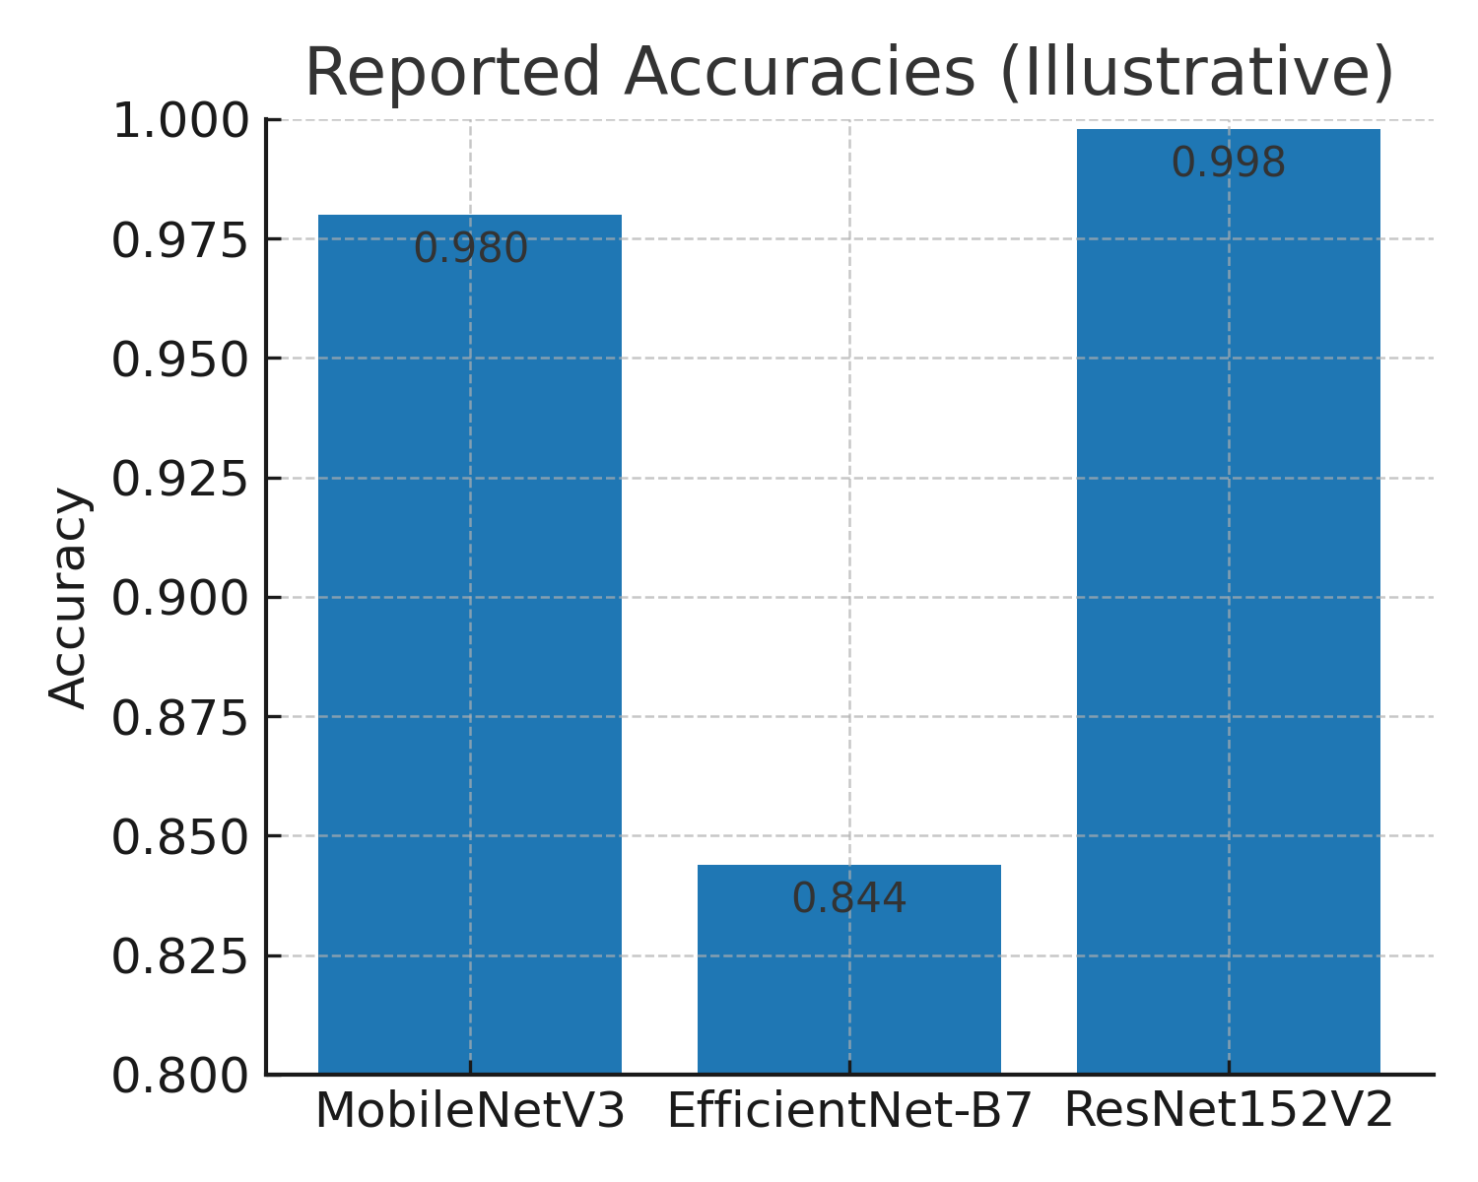 *Figure 2.3* *Reported Accuracies for MobileNetV3, EfficientNet-B7, and ResNet152V2*Figure 2.3 shows documented classification accuracies for three deep learning architectures MobileNetV3, EfficientNet-B7, and ResNet152V2 derived from the papers Searching for MobileNetV3, A state-of-the-art survey on deep learning theory and architectures and Identity Mappings in Deep Residual Networks. The values indicate the top 1 accuracy documented in benchmark image classification datasets within the referenced studies. (Howard, 2019), (Md Zahangir Alom, 2019), (He, Zhang, Ren, & Sun, 2016)

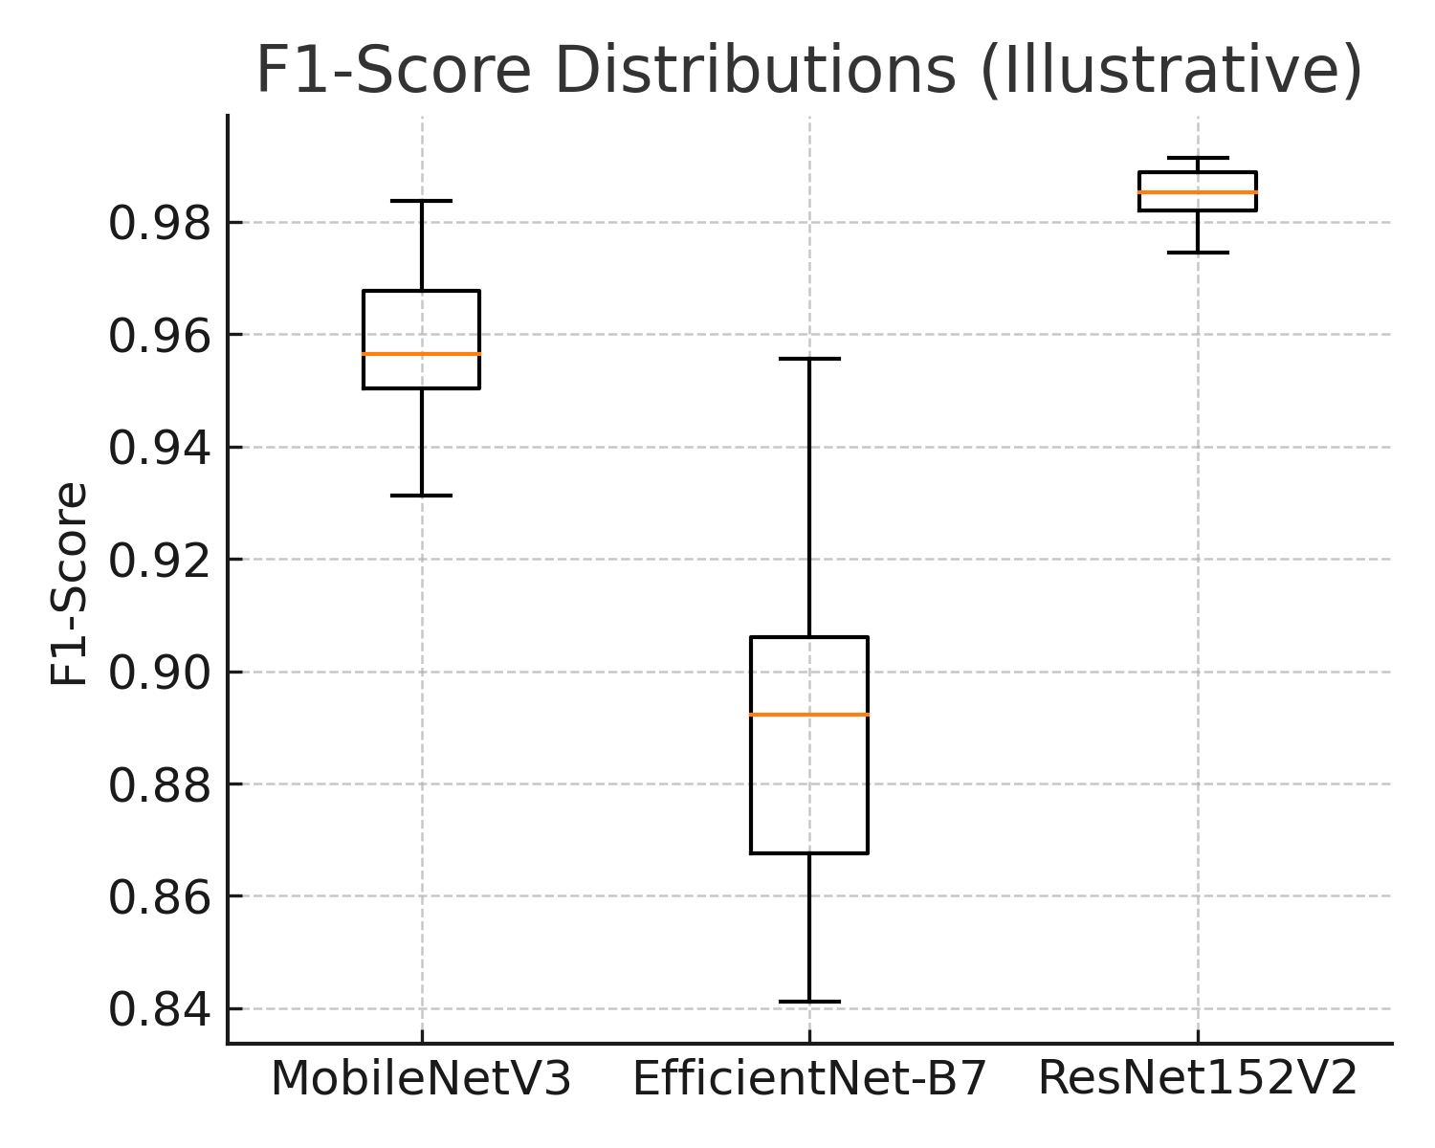

*Figure 2.4 Illustrative F1-Score Distributions for three deep learning architectures MobileNetV3, EfficientNet-B7, and ResNet152V2* (Howard, 2019)*,* (He, Zhang, Ren, & Sun, 2016)*,* (Md Zahangir Alom, 2019)

Figure 2.4 illustrating F1-Score Distributions for three deep learning architectures MobileNetV3, EfficientNet-B7, and ResNet152V2 derived from the papers Searching for MobileNetV3, A state-of-the-art survey on deep learning theory and architectures and Identity Mappings in Deep Residual Networks. The F1-score is the harmonic means of precision and recall, offering a balanced assessment of a classifier's accuracy by considering both false positives and false negatives. In this figure, the orange line shows the median, and each box shows the interquartile range (IQR) of F1-scores.  
The whiskers show how much the scores vary by going from the lowest to the highest non-outlier values. MobileNetV3 and ResNet152V2 have high median F1-scores and small IQRs, which means that they perform well and consistently throughout test runs.  
EfficientNet-B7 still works well, but its F1-scores are more spread out, which means that performance is less stable. This visualization is very helpful for assessing the robustness and dependability of models beyond the average measures.

Precision and Recall:  
  
Precision and recall are important for testing binary and multi-class classifiers, especially when it comes to finding diseases when the penalty of making wrong selections is not the same. Precision (Positive Predictive Value) tells you how reliable positive predictions are:

Precision=TP/FP+TP​

A high level of accuracy indicates that the system is typically right when it identifies an animal as sick. This helps save healthy cattle from being isolated or treated when they don't need to be.

Recall (Sensitivity/True Positive Rate) assesses how well you can find real positives:

Recall=TP/FN+TP​

A high recall indicates that the system doesn't miss many seriously ill animals, which is very important for illnesses that spread quickly (like FMD) since false negatives can make the disease spread quickly in the herd. Because these metrics are related to each other through the decision threshold, people often look at them using precision-recall (PR) curves, PR scatter plots across thresholds, and summary bars (like model-level precision and recall). In cases where healthy photos are far more common than ill ones, which is common, PR analysis is typically more useful than ROC analysis. (Saito & Rehmsmeier, 2015)

**Disease Context: Lumpy Skin Disease (LSD) and Foot and Mouth Disease (FMD)**

Lumpy Skin Disease (LSD) is a Capri poxvirus illness that affects cattle and water buffalo. It produces fever, hard skin nodules, swelling, lymphadenitis, mastitis, and secondary infections. It is not zoonotic. In outbreaks, the average rate of illness is around 10–20%, and the usual rate of death is about 1–5%. However, greater rates of illness have been seen in naïve herds and explosive waves. Production effects include big declines in milk production, weight loss, infertility/abortion, emaciation, and damaged hides. Movement and trade limitations that make losses worse are also a problem (World Organisation for Animal Health (WOAH), 2024). The main way it spreads is by mechanical transmission by blood-feeding arthropods such biting flies, mosquitoes, ticks, and maybe midges. Direct contact is considered to play a little role; the virus is found in skin nodules, scabs, and crusts that can stay infectious for weeks. Iatrogenic dissemination (for example, by needles) has also been seen. So, control combines vector management with movement control and immunization (Australian Government Department of Agriculture, Fisheries and Forestry, 2023). Since 2021–2023, there have been large outbreaks in Asia, such as Thailand's first wave, which had a morbidity rate of 40.5% and a mortality rate of 1.2% (World Organisation for Animal Health (WOAH), 2024). India's 2022 wave affected more than 2 million cattle, and the peak media and government reporting for that season showed more than 110,000 deaths (Agrawal, Sharma, Singh, & Varga, 2024). Studies of the economy on farms suggest that the average loss per outbreak farm is around US$727. This is because of deaths and less milk sales, as well as the costs of treatment and immunization (World Organisation for Animal Health (WOAH), 2024). Lumpy Skin Disease (LSD) outbreaks can be clustered and vector-driven, hence the number of cases on a farm might change a lot during vector seasons. For model evaluation, this makes precision/recall and F1 very useful in addition to accuracy. This is because false positives (FP) can lead to excessive expenses for isolation and culling, while false negatives (FN) can let disease spread throughout the herd and cause milk loss. Metrics produced from confusion matrices directly correlate to biosecurity choices in the context of vector pressure.

Foot and Mouth Disease (FMD) is a very infectious Aphthovirus illness that affects animals with split hooves, such cows, buffalo, sheep, goats, and pigs. In vulnerable herds, morbidity can reach almost 100%; fatality rates are generally 1–5% in adults but exceed 20% in young stock owing to myocarditis or agalactia. The time it takes for the disease to spread is between 2 to 14 days. Direct contact, aerosols, milk and semen, and fomites (people, cars, equipment) are all ways that the virus may spread. It has also been shown to transmit via the air over long distances. If you don't manage mobility and vaccinate, high contagion and multi-route shedding will certainly cause fast amplification among the herd (World Organisation for Animal Health (WOAH), 2024). Foot and Mouth Disease (FMD) has a low death rate but a large burden. It is thought to cost the world $6.5 to $21 billion a year in lost output and immunization in areas where it is common. Foot and Mouth Disease (FMD) outbreaks on farms lead to significant milk losses; for example, a recent meta-analysis found that afflicted cows lost around 846 kg of fat-corrected milk per cow in impacted lactations. In chronic situations, historical studies reveal that yields can drop by as much as 80%. Fertility and growth are also affected. Costs that aren't direct include immunization, limits on migration, and losses of access to markets (Knight-Jones, 2013). Sensitivity and recall are very important since almost all naïve herds get sick and there are serious trade penalties for missing positives. However, accuracy must stay high so that healthy animals don't have to stop moving for no reason. So, F1-score and PR curves work with accuracy/AUC to find the right balance between FP and FN policy costs while sorting through a lot of photos.

The dissemination of LSD is facilitated by vectors, whereas FMD transmission occurs by touch or aerosol, resulting in elevated herd-level attack rates; hence, the costs associated with false negatives and false positives are asymmetrical and contingent upon context. This report will consequently include confusion matrices and metrics such as precision, recall, and F1 score for each class (LSD vs. FMD), in addition to accuracy, to represent actual control priorities (quick detection versus excessive isolation). Where relevant will address threshold selection and confidence calibration to facilitate field deployment choices.

2.4. Justification for planning decisions

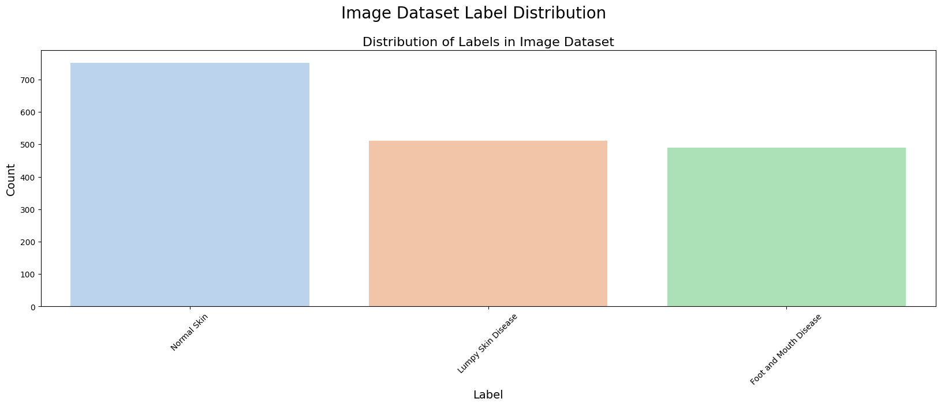

*Figure 2.5 Distribution of labels in the image dataset*

Figure 2.5 illustrates the allocation of photos across the three dataset categories: Normal Skin, Lumpy Skin Disease, and Foot and Mouth Disease. The dataset exhibits a relatively balanced composition, comprising roughly 750 normal cases, 500 lumpy skin disease cases, and 500 foot-and-mouth disease cases. This balance is crucial in machine learning as it mitigates the danger of bias towards majority classes and enhances robust model generalization.

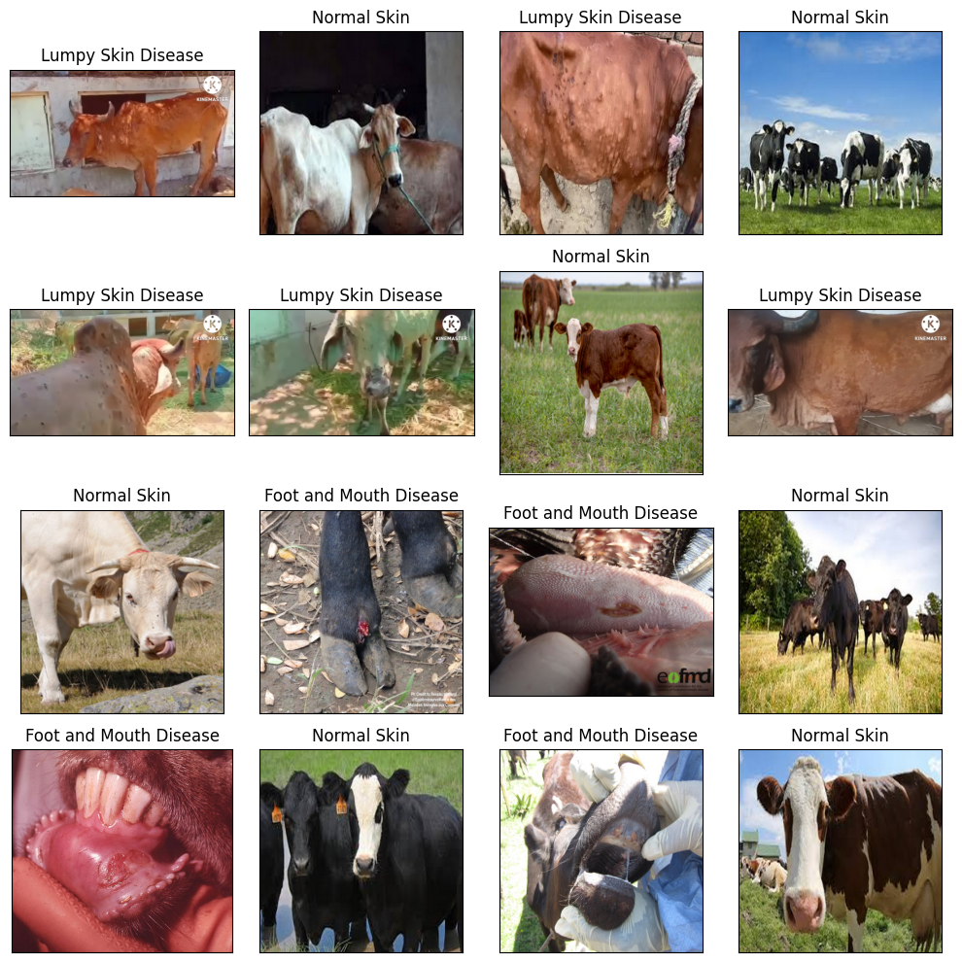

*Figure 2.6 Representative examples of cattle skin images from the dataset across the three classes.*

Figure 2.6 depicts exemplary photos from each category. This qualitative analysis emphasizes the intrinsic visual intricacy of bovine disease manifestations, including nodular lesions in lumpy skin disease and oral lesions linked to foot and mouth disease. The existence of diverse climatic circumstances, variations in illumination, and different cow breeds within the dataset further substantiates the implementation of a deep transfer learning architecture. ResNet152V2 was chosen for its capacity to extract high-level discriminative features from intricate visual input, which is essential for precise cattle disease identification.

3. Technical Solution

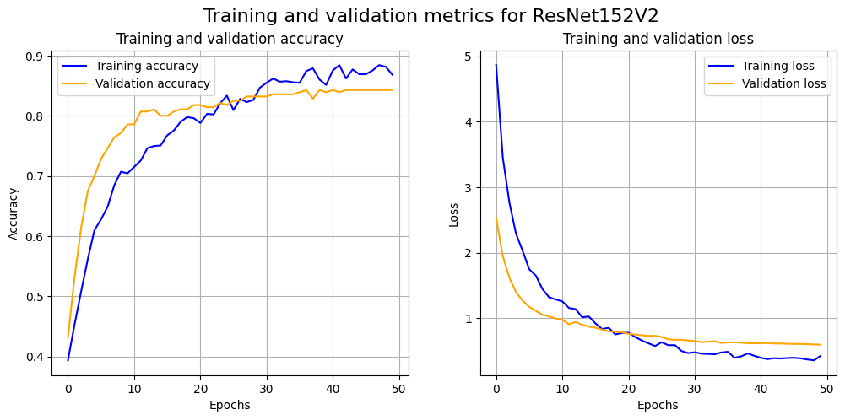

*Figure 3.1: Training and validation accuracy/loss curves for ResNet152V2.*

Figure 3.1 depicts the training and validation accuracy and loss trajectories for the ResNet152V2 model. Training accuracy progressively enhances after 50 epochs, approaching 90%, whilst validation accuracy remains consistent at about 85%. The associated loss curves have a distinct decreasing trajectory, with validation loss stabilizing, signifying successful convergence with negligible overfitting. This behavior validates that the selected architecture and hyperparameter setup attained both stability and generalization.

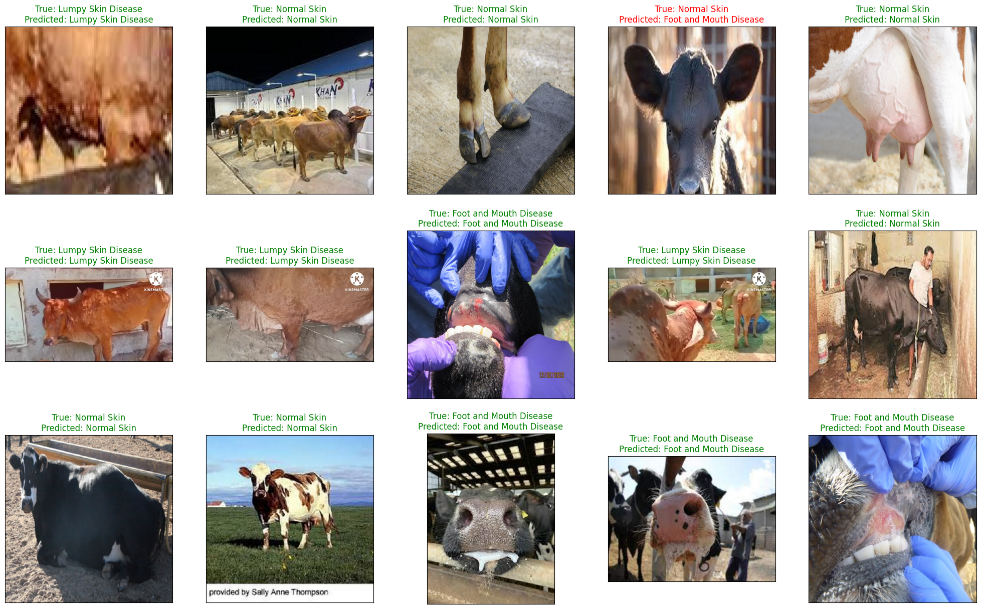

*Figure 3.2: Example predictions on test dataset images with ground-truth labels.*

Figure 3.2 displays random predictions on test set samples for a more comprehensive assessment of model performance. Accurate forecasts are shown in green, whilst erroneous ones are emphasized in red. Most test samples were correctly categorized, with mistakes mostly arising in instances when clinical symptoms were visually modest or obscured by background noise. This substantiates the conclusion that although the model has robust predictive capability, more enhancements are necessary to reduce clinically important misclassifications.

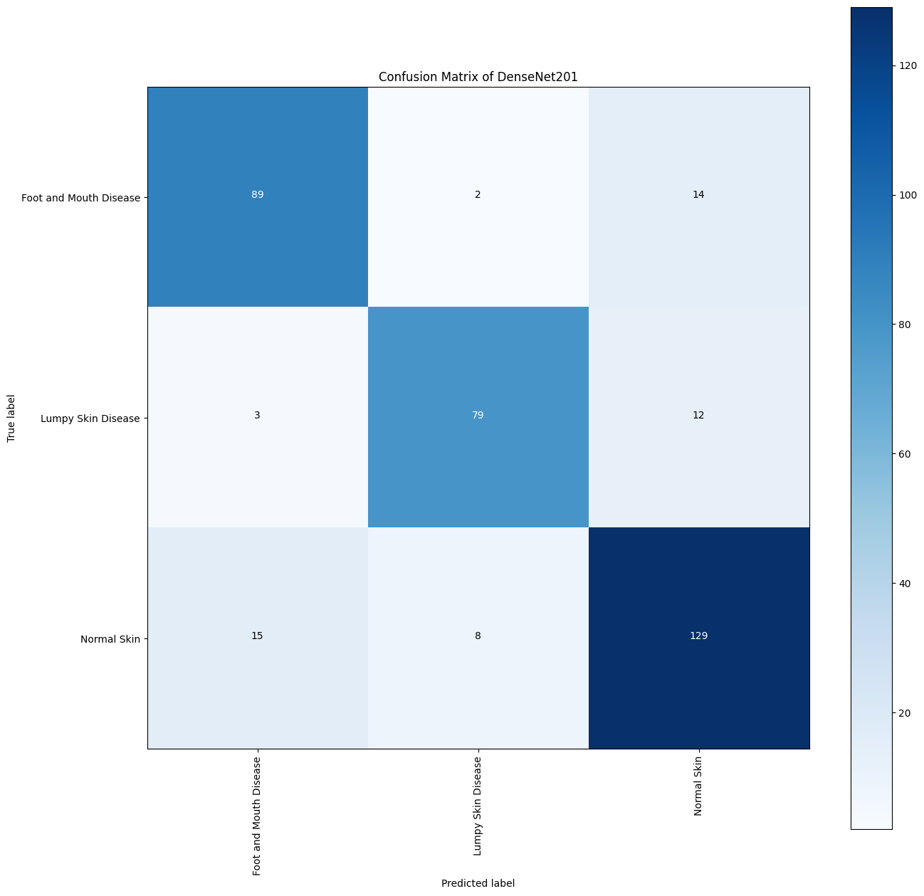

*Figure 3.3: Confusion matrix of ResNet152V2 predictions on the test dataset.*

Figure 3.3 illustrates the confusion matrix for the ResNet152V2 model utilized on the test dataset. Most predictions align with the diagonal, signifying accurate classifications among the three categories: Foot and Mouth Disease, Lumpy Skin Disease, and Normal Skin. Significant misclassifications are evident, including 14 instances of foot and mouth disease erroneously identified as normal skin and 12 cases of lumpy skin disease similarly misclassified. These inaccuracies are critical in a veterinary environment, since false negatives (diseased animals misclassified as healthy) may lead to untreated infections and subsequent disease transmission. Conversely, false positives, shown by 15 normal instances misclassified as sick, provide a reduced clinical risk but may lead to superfluous veterinary procedures. The confusion matrix illustrates the model's robust performance while emphasizing the necessity for tuning to minimize false negatives in illness diagnosis.

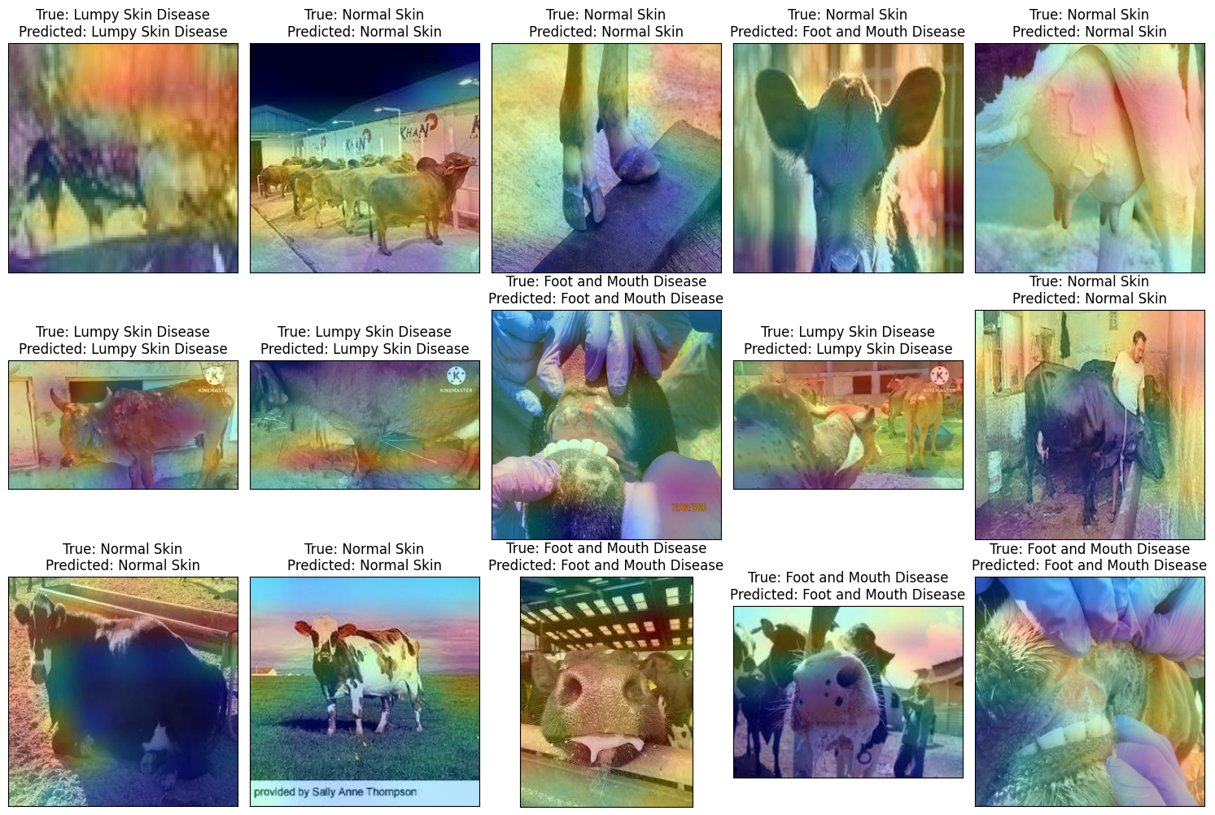

*Figure 3.4: Grad-CAM visualizations showing model attention regions for correctly and incorrectly classified samples.*

Figure 3.4 illustrates Grad-CAM visualizations, which emphasize the areas of input photos that significantly influenced the model's predictions. The heatmaps indicate that the model concentrates on clinically significant areas: nodular lesions in lumpy skin disease, oral lesions in foot-and-mouth disease, and healthy skin regions in normal cattle. This signifies that the model is acquiring significant and domain-specific characteristics instead of depending on extraneous background artefacts. Interpretability approaches like Grad-CAM augment transparency and foster confidence in AI-driven veterinary diagnostics, rendering them essential tools for field applications where explainability is vital for decision-making.

3.1. Architectural model

3.2. System design

3.3. Data design

3.4. User Experience Design

4. Testing, Verification and Validation

4.1. Testing

4.2. Verification

4.3. Validation

5. Evaluation

5.1. Outcomes

5.2. Project management

5.3. Tools

5.4. Innovation (if any)

5.5. Context

6. Conclusion

References

Appendix A - Code Manifest

Additional appendices

# References

A. O’Shea, J. N. (2019). An introduction to convolutional neural networks. *arXiv preprint arXiv:1905.02244*.

Allen Daniel Sunny, S. K. (2018). Disease diagnosis system by exploring machine learning algorithms. *International Journal of Innovations in Engineering and Technology (IJIET), 10*(2), 82–89. Retrieved 2025 11, August, from https://ijiet.com/wp-content/uploads/2018/06/3.pdf

Daksh Ashar1, A. K. (2021). Livestock Disease Prediction System. *VIVA‑Tech International Journal for Research and Innovation, 1*(4), 1–3. Retrieved August 11, 2025, from https://www.viva-technology.org/New/IJRI/2021/97.pdf

Deeksha G Mesta, J. R. (2023). Cattle disease prediction using machine learning: A systematic review. *Grenze International Journal of Engineering and Technology (GIJET), 9*(1), 187–193. Retrieved from https://thegrenze.com/index.php?absid=1431&display=page&id=8&view=journalabstract

Dihua Wu, Q. W. (2020). Lameness detection of dairy cows based on the YOLOv3 deep learning algorithm and a relative step size characteristic vector. *Computers and Electronics in Agriculture, 178*, 105–115. doi:10.1016/j.biosystemseng.2019.11.017

Erin Hennesey, M. D. (2022). Artificial intelligence in veterinary diagnostic imaging: A literature review. Veterinary Radiology & Ultrasound. *Artificial intelligence in veterinary diagnostic imaging, 63*(1), 14–28. doi:10.1111/vru.13072

*F1 Score in Machine Learning: Formula, Precision, and Recall*. (2025, May 10). Retrieved August 11, 2025, from capalearning.com: https://capalearning.com/2025/05/10/f1-score-in-machine-learning-formula-precision-and-recall/

Food and Agriculture Organization of the United Nations (FAO). (2017). *Lumpy Skin Disease (LSD) Field Manual: A Manual for Veterinarians.* Rome: Food and Agriculture Organization of the United Nations (FAO).

*geeksforgeeks*. (2025, May 30). Retrieved from geekforgeeks: https://www.geeksforgeeks.org/machine-learning/confusion-matrix-machine-learning/

Haroon Afzal, M. U.‑T. (2024). Lumpy Skin Disease: An Encroaching Risk in Cattle Farming. *Taiwan Veterinary Journa, 49*(1), 11. doi:10.1142/S1682648524300016

He, K., Zhang, X., Ren, S., & Sun, J. (2016, July 25). Identity Mappings in Deep Residual Networks. *rXiv preprint arXiv:1603.05027*. doi:10.48550/arXiv.1603.05027

*How do Convolutional Neural Networks (CNNs) Work?* (2024). Retrieved from GeeksforGeeks: https://www.geeksforgeeks.org/computer-vision/how-do-convolutional-neural-networks-cnns-work/

Howard, A. S. (2019). Searching for MobileNetV3. *Proceedings of the IEEE/CVF International Conference on Computer Vision (ICCV)* (pp. 1314–1324). Seoul: IEEE. doi:10.1109/ICCV.2019.00149

Jayapratha N, S. P. (2025, March). Deep Learning-Based Real-Time Detection of External Diseases in Cattle Using Computer Vision. *International Journal of Research Publication and Reviews, 6*(3), 7330-7338. Retrieved August 11, 2025, from https://ijrpr.com/uploads/V6ISSUE3/IJRPR40711.pdf

Khandait, P. D., Lanjewar, K., Patle, S., & Meshram, R. (2025). Deep Learning-Based Cattle Disease Detection: A CNN Approach for Identifying Lumpy Skin Disease and Foot-and-Mouth Disease. *11th Volume, Issue 10, IJIRT (International Journal of Innovative Research in Technology)* (pp. 1068–1077). Nagpur: IJIRT. Retrieved August 11, 2025, from https://ijirt.org/article?manuscript=173676

Laith Alzubaidi, J. Z.-D.-S.-A. (2021). Review of deep learning: concepts, CNN architectures, challenges, applications, future directions. *Journal of Big Data, 8*(1), Article 53. doi:10.1186/s40537-021-00444-8

Lijing Niu, C. Y. (2020). Cattle Disease Auxiliary Diagnosis and Treatment System Based on Data Analysis and Mining. *2020 5th International Conference on Computer and Communication Systems (ICCCS)* (pp. 24–27). Shanghai, China: IEEE. doi:ICCCS49078.2020.9118590

Md Zahangir Alom, T. M. (2019). A state-of-the-art survey on deep learning theory and architectures. *arXiv preprint arXiv:1905.11946*. doi:10.48550/arXiv.1905.11946

Mrs. Anitha Rao, M. H. (2023). Cattle Disease Prediction Using Artificial Intelligence. *International Journal for Research in Applied Science and Engineering Technology (IJRASET), 11*. doi:IJRASET.2023.50535

Powers, D. M. (2011). From precision, recall and F-measure to ROC, informedness, markedness and correlation. *Journal of Machine Learning Technologies, 2*(1), 37–63. Retrieved August 11, 2025, from https://bioinfopublication.org/files/articles/2_1_JMLT.pdf

Saito, T., & Rehmsmeier, M. (2015, March 4). The precision‑recall plot is more informative than the ROC plot when evaluating binary classifiers on imbalanced datasets. *PLOS ONE, 10*(3), 1-21. doi:journal.pone.0118432

Saqib, S. M., Iqbal, M., Tahar Ben Othman, M., Shahazad, T., Yasin Ghadi, Y., Al-Amro, S., & Mazhar, T. (2024, August 5). Lumpy skin disease diagnosis in cattle: A deep learning approach optimized with RMSProp and MobileNetV2. *PLOS ONE, 19*(8). doi:journal.pone.0302862

Senthilkumar, C., C, S., Vadivu, G., & Neethirajan, S. (2024). Early Detection of Lumpy Skin Disease in Cattle Using Deep Learning—A Comparative Analysis of Pretrained Models. *Veterinary Sciences, 11*(10), Article 510. doi:vetsci11100510